Understand the Problem:
Why data structures and algorithms matter:
- In a warehouse with potentially thousands of products, efficient search, update, and delete operations are necessary.
- Without good data structures, operations become slow and memory inefficient, especially as inventory grows.

Suitable Data Structures:
- HashMap is a strong choice:
  - Fast lookup (O(1) on average) using productId as the key.
  - Easy to update and delete.

- ArrayList is another option, but:
  - Requires linear search (O(n)) for lookup/update/delete by productId.
  - Best suited when order matters or productId is not unique.

Analysis:
Operation | Time Complexity(HashMap) | Explanation
addProduct() | O(1) average | Uses put()
updateProduct() | O(1) average | Uses get()
deleteProduct() | O(1) average | Uses remove()
showAllProducts() | O(n) | Iterates through values

Optimization:
- If real-time inventory sync is needed, use ConcurrentHashMap in multithreaded environments.
- For persistence, integrate with a database (e.g., MySQL).
- Add search by name using a Map<String, List<Product>> if needed.

Code:
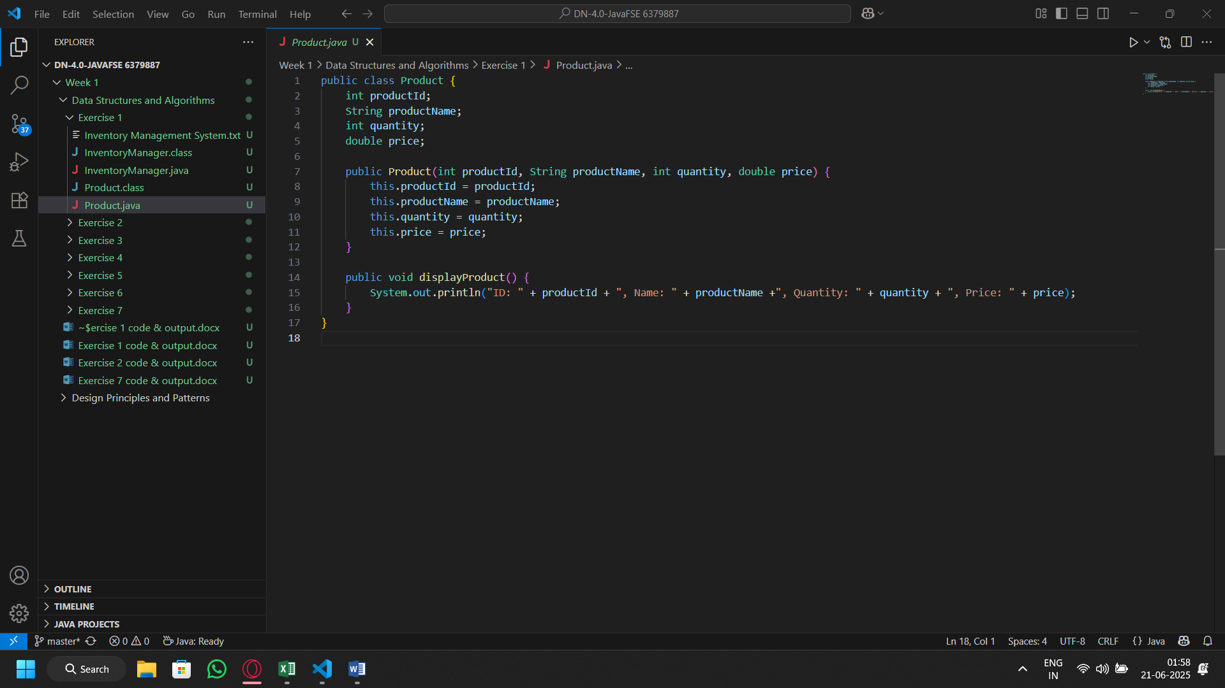
Product class

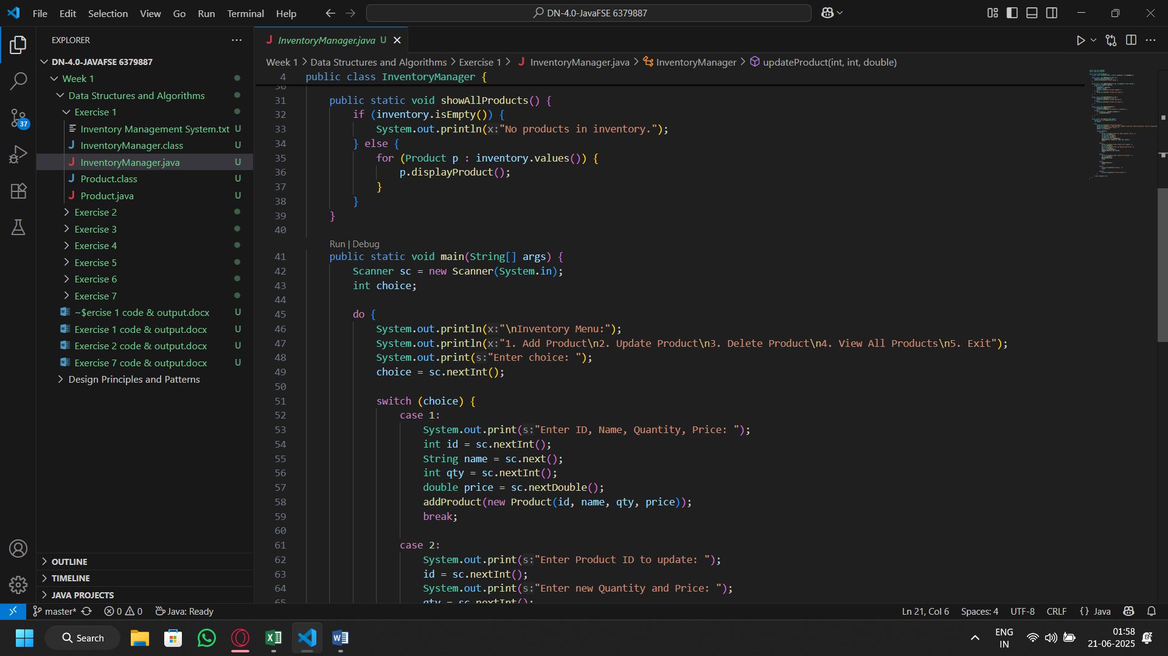
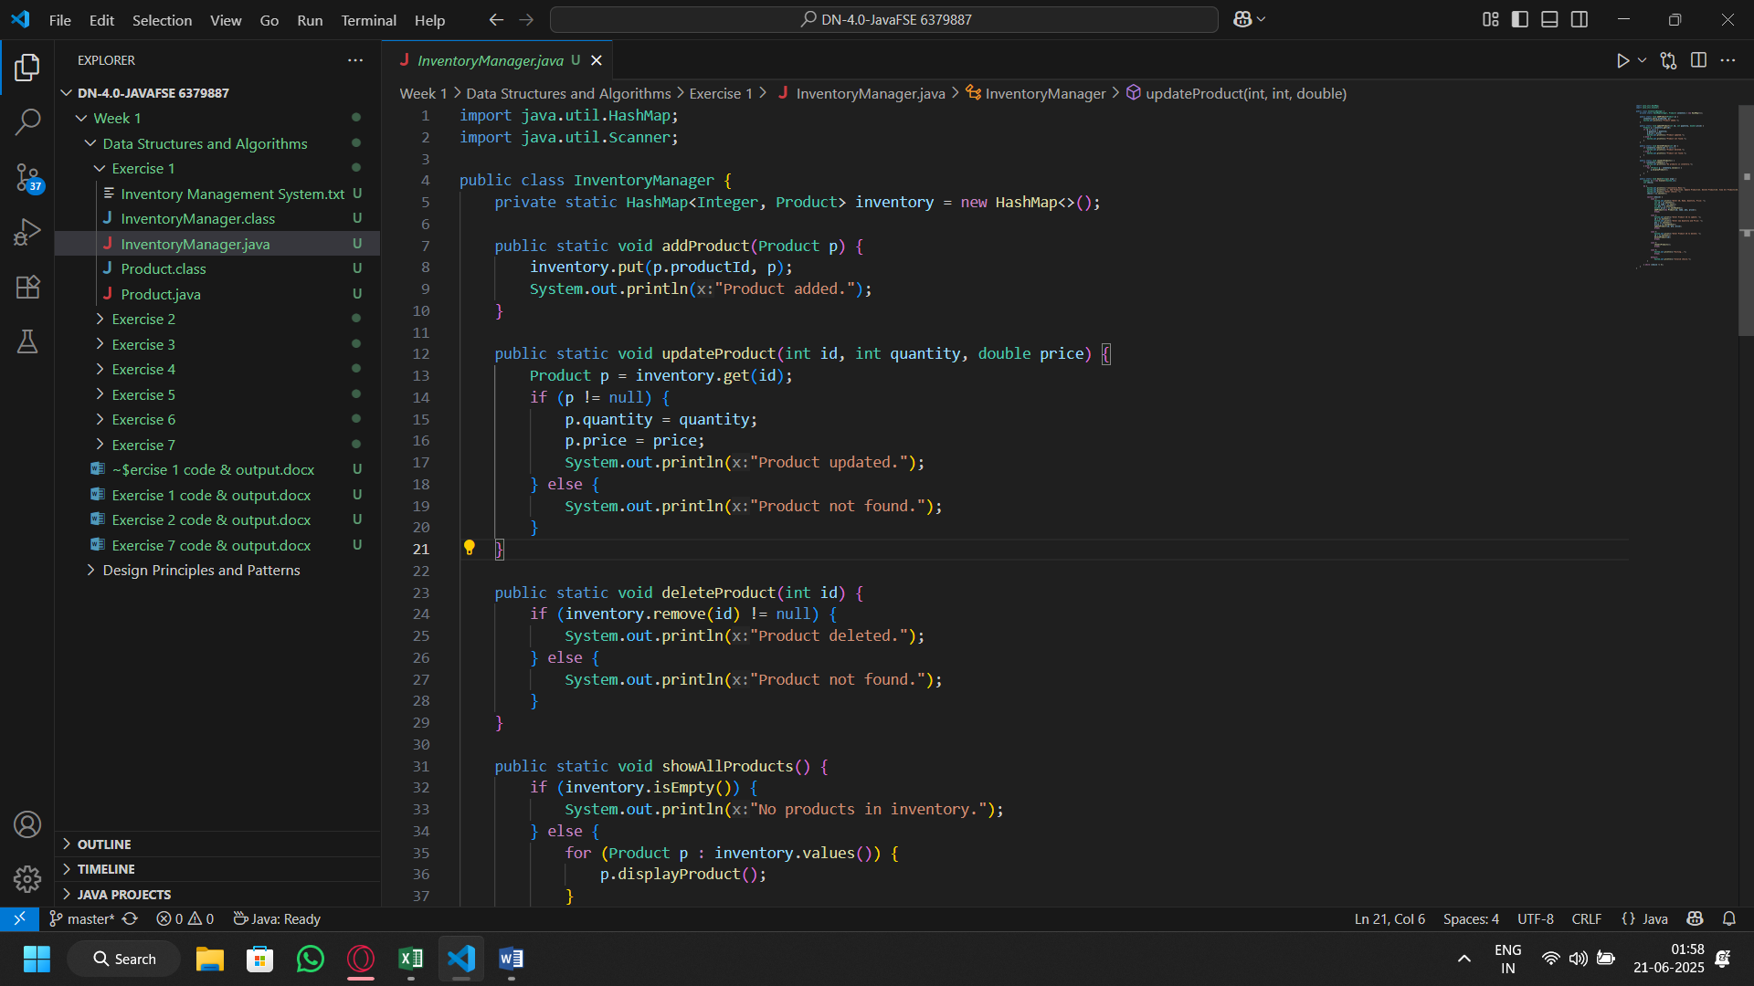
Inventory Manager Class
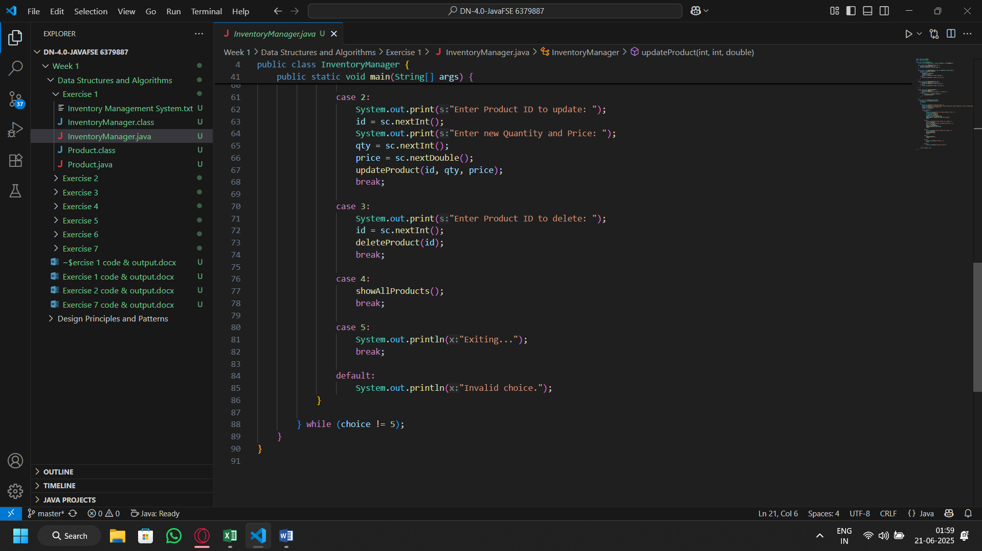

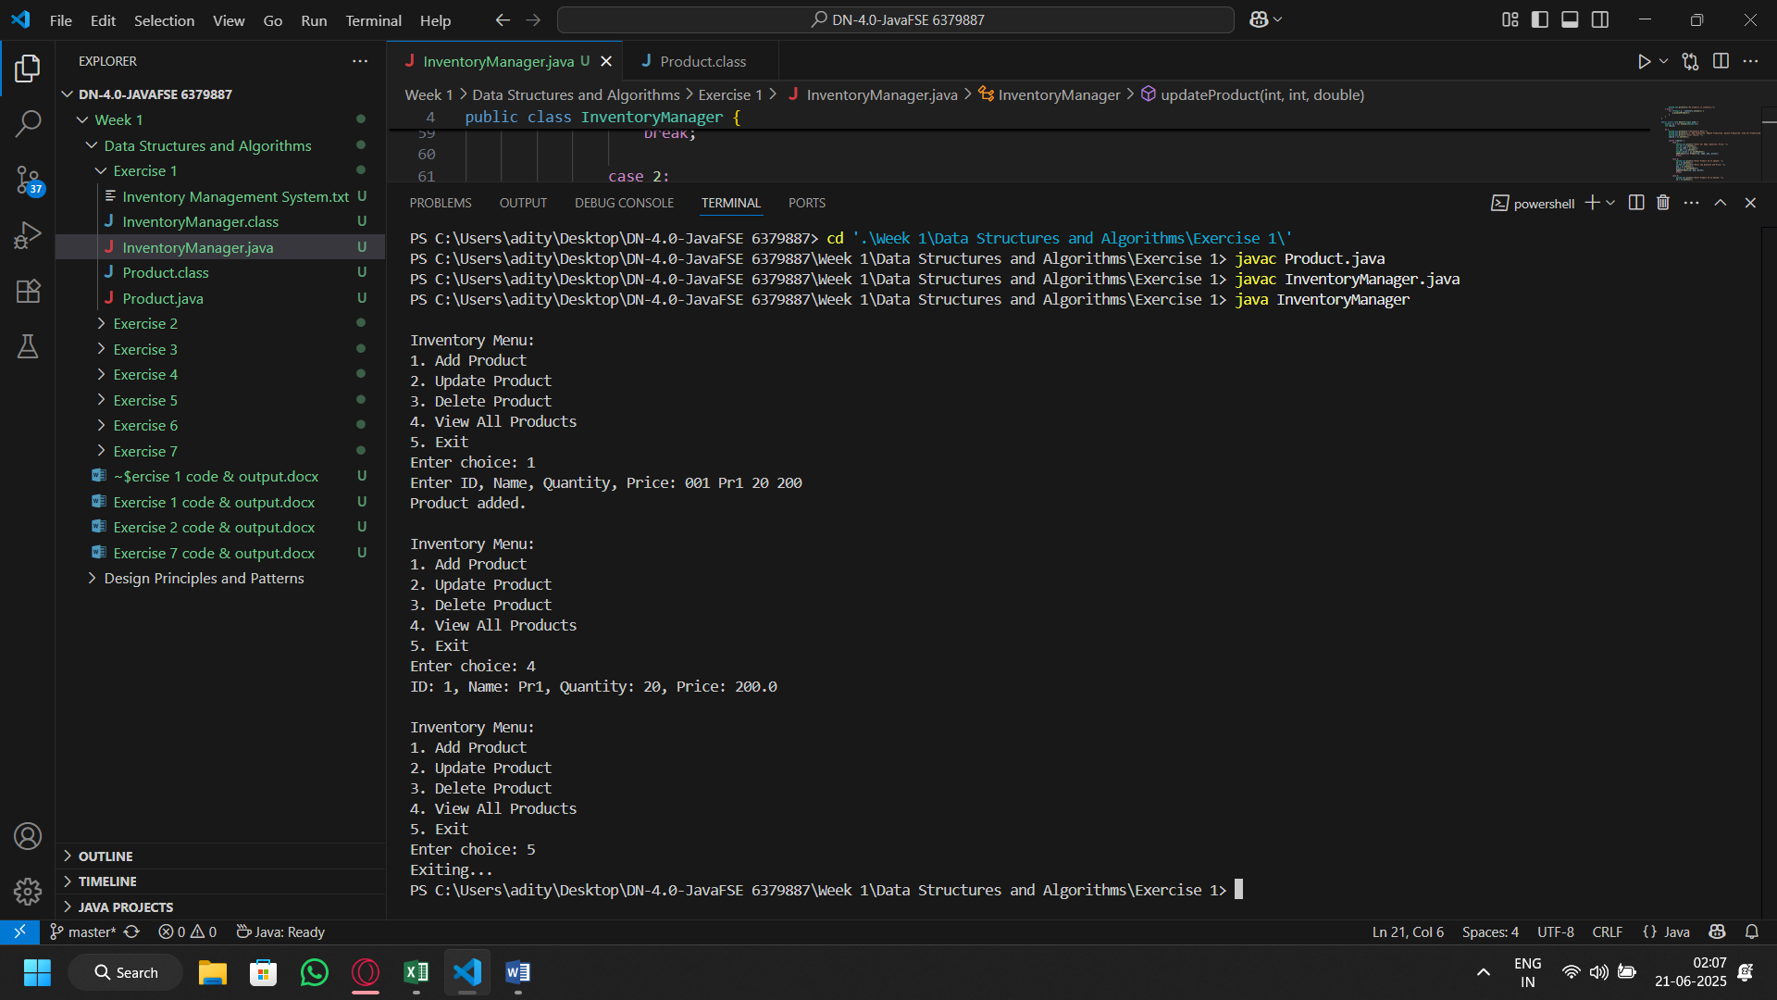
Output:

